Assignment-1
Section: 1 – Multiple choice
- Which of the following is NOT a component of the CPU?
- ALU
- RAM
- CU
- 1 and 3 both
Ans. -> B. RAM
- What is the function of RAM in a computer?
Ans. -> The main function of RAM is to store temporary store the data of the particular task that the pc is currently doing. It works as a volatile memory that means it loss the memory when powered off.
- Which of the following is a primary storage device?
  - HDD
  - SSD
  - SD card
  - 1 and 2 both
Ans. -> D. 1 and 2 both
- What is the purpose of a GPU?
  - The primary purpose of GPU is to make 2D and 3D graphics, animation, videos and providing high picture quality and smooth visual for screens.
- Besides this the original purpose of GPUs was to offload simple designing tasks from CPUs.
- It’s also used in machine learning and scientific computing for the same reason.

Section 2: True or False

- True or False: The motherboard is the main circuit board of a computer where other components are attached.
Ans. -> True

- True or False: A UPS (Uninterruptible Power Supply) is a hardware device that provides emergency power to a load when the input power source fails.
Ans. -> True

- True or False: An expansion card is a circuit board that enhances the functionality of a component.
Ans. -> True
Section 3: Short Answer
- Explain the difference between HDD and SSD.
Ans. ->
HDD | SSD
Stands for Hard Disk Drive | Stands for Solid State Drive
Stores data in Disks | Stores data in chipsets
HDD have moving parts and subject to sudden failure. | SSD have no moving parts to fail
Slower boot times and file access. | Much faster boot times and file access.
Produces noise due to spinning disks | Operates silently
Require more power because there are two motors so needs more power typically 6-12 watts | Needs less Power  Typically, 2watts
Stores temporary files | Doesn’t store temporary files
Random access time 5-10 ms | Random access time 0.1 ms.
Read latency time high | Read latency time very low.
50MB/s to 100MB/s | 100MB/s to 500MB/s
Low reliability. | High Reliability.
Relatively large and heavy | Small and light weight.
Till now HDD are available up to 4TB | Till now SSD are available in size to 2TB
Ideal for budget-friendly, high-capacity storage | Best for high-speed computing, gaming, and fast system performance.

- Describe the function of BIOS in a computer system.
Ans. -> BIOS stands for Basic Input/Output System. BIOS is the first program to run when the computer starts. It initializes, tests, and configures hardware components (CPU, RAM, drives) during bootup. It performs the Power-On Self-Test (POST) to ensure functionality, loads the operating system o manage input/output devices like keyboards and monitors.
- Key functions of BIOS:
- Power-On Self-Test (POST): During the boot process, the BIOS performs a series of tests on the hardware components, such as the CPU, memory, and storage devices, to check if they are functioning properly. If any issues are detected, the BIOS may display error messages or emit beep codes to alert the user.
- System Configuration: The BIOS allows users to configure various system settings, such as the boot order of devices, date and time, and hardware parameters. These settings can be accessed and modified through the BIOS setup utility, which is typically accessed by pressing a specific key during the boot process, such as F2 or Del.
- Device Initialization: The BIOS initializes all the hardware components of the computer, including the CPU, memory, storage devices, and peripheral devices, such as keyboard and mouse. It provides the necessary instructions for these devices to start functioning and communicate with the operating system.
- Boot Loader: The BIOS contains a boot loader, which is a small program that loads the operating system into memory and starts its execution. The boot loader reads the boot sector of the storage device, which contains the initial instructions for the operating system to start loading.
- Firmware Updates: The BIOS can be updated with new firmware to fix bugs, improve compatibility, and add new features. Firmware updates are typically provided by the motherboard manufacturer and can be installed using a utility provided by the manufacturer.

- List and briefly explain three input devices commonly used with computers.
Ans. -> An input device lets you communicate with a computer. You can use input devices to enter information and issue commands. These devices enable us to interact with the computer and accomplish tasks.
- Different Input Devices:
- Keyboards: Keyboard is the most common and commonly used input device. It allow users to input text and commands.
- It contains different keys for entering letters, numbers, and characters.
- Supports multiple layouts
- Connects via USB, wireless, or integrated in devices like laptops.
- Types of Keyboards are:
    - Standard keyboards
    - Laptop keyboards
    - Gaming keyboards
    - Laser or infrared keyboards
    - Rollup keyboards
- Mouse: The mouse is a small handheld device commonly used to point and control the cursor on a computer screen.
- Includes buttons and scroll wheel for clicking, selecting, and navigating.
- Available in wired, wireless, or optical variants.
- Used to select, drag, and open files or programs.
- Works on a flat surface for movement.
- Types of mouse are:
    - Cordless(wireless)
    - Optical Mouse
    - Mechanical Mouse
    - Trackball
- Scanner: A scanner is a type of input device that works in the same way as a photocopier. It's used when there's data on paper that needs to be transferred to the computer's hard disk for further processing.
- Scan images or text from physical documents.
- Converts paper-based data into digital format for storage.
- Enables editing of scanned images before printing.
- Types of scanners:
    - Flatbed Scanner
    - Sheet Fed Scanner
    - Drum Scanner
    - Slide Scanner
    - Handheld Scanner
Section 4: Practical Application
- Identify and label the following components on a diagram of a motherboard:
  - CPU
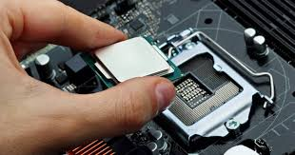
  - RAM slots
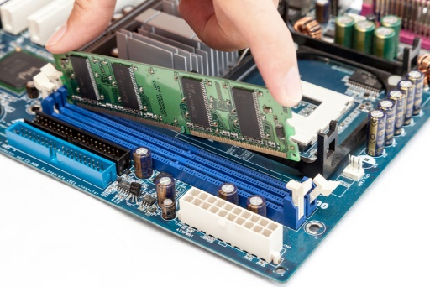
  - SATA connectors
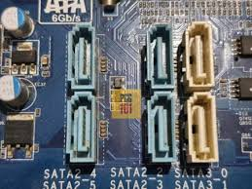
  - PCI-E slot
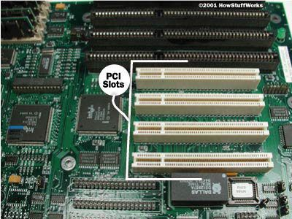
- Demonstrate how to install a RAM module into a computer.
  - First power off the computer and unplug the power supply of cabinet.
  - Open the cabinet using screwdriver.
  - Find the empty ram slot in motherboard.
  - Open clips of ram slot and align ram with the slot.
  - Push it in the slot until the clips gets back to their places.
  - Close the cabinet, plug power supply back and start computer for verifying the installation of RAM.

Section 5: Essay

- Discuss the importance of proper cooling mechanisms in a computer system. Include examples of cooling methods and their effectiveness.
- Proper cooling mechanisms are important in a computer system because they prevent overheating, which can cause performance throttling, system instability, hardware damage, and reduced lifespan of components like the CPU, GPU, and motherboard. Effective cooling helps maintain stable temperatures, ensuring reliable performance and safe operation.
The importance of Proper cooling mechanism:
  - Prevent Thermal throttling: Basically, Thermal throttling is a built-in safety feature where a computer's CPU or GPU automatically reduces its performance (clock speed) when it gets too hot, preventing permanent damage from overheating, but causing slowdowns, lag, and stuttering as a result. Proper cooling ensures the system maintains maximum performance without throttling.
  - Extending Component Life: Excessive heat can make the components less usable and can be damaged or harmed sometimes. Maintaining a lower temperature directly contributes to high use and less damage of those components.
  - System Stability: Over heating can causes crash of system or sometime lag the system’s performance. It can interrupt the task sometime.
  - For protecting Hardware: Sometimes extreme heat can melts solder.
- Examples of cooling Methods and their effectiveness:
- Air Cooling:
Also known as Active cooling.
Basically, A Traditional method for cooling. It uses cooling fan and a heat sink typically uses metals like aluminium and copper for controlling temperature.
  - Effectiveness:
Generally, very effective on the system who have standard to moderate workloads.
Best for budget-conscious users.
- Liquid Cooling:
Circulates liquid coolants to absorb and remove heat from components.
Generally, water is used as a liquid coolant with some additives. It absorbs heat from the system.
  - Effectiveness:
Highly effective
Mostly reduces temperature by 10-20°C
More effective than air cooling
Best for Gaming and Video editing and in the system who have high workloads.
- Passive cooling:
We can say a lower version of air-cooling system.
In this the system uses only heatsinks without fans, fully depends on natural air.
  - Effectiveness:
Often very low
Generally, suitable for low-power components

- Advanced Cooling:
Advanced / Exotic Cooling methods are used when standard air or liquid cooling is not enough, usually in overclocking, research, or extreme performance systems.
Uses extremely cold liquid nitrogen poured directly onto the system.
- Effectiveness:
Highly effective
Can cool system below the ambient temperature.

- Explain the concept of bus width and its significance in computer architecture.
  - Bus width refers to the number of bits that can be transferred simultaneously over a computer’s data bus.
  - We can also say that bus width refers to refers to the number of parallel electrical pathways (lines) in a computer bus, determining how many bits of data can be transferred simultaneously between components like the CPU, memory, and peripherals in one clock cycle. It directly impacts system performance, with wider buses (e.g., 64-bit) offering higher data throughput compared to narrower ones.
  - For example, a 32-bit bus can carry 32 bits of data at one time, while a 64-bit bus can carry 64 bits.
Significance of Bus width:
  - A wider bus allows more data to be sent in a single cycle
  - A 64-bit bus can transfer double the data of a 32-bit bus in the same amount of time
  - The data bus width determines how much data is transferred, while the address bus width determines the maximum amount of addressable memory.
  - The primary determinant of how fast data moves between the processor and memory.
  - Wider address buses enable the system to support larger amounts of RAM.
  - A narrow bus can restrict a fast CPU, creating a bottleneck that slows down the entire computer.
  - Bus width is a critical factor, along with clock speed, in determining the overall system bandwidth.

